Authentication Middleware

📝Definition
# Source: AI Source: Provided by: [Data Path: Persons Table -> ID Column: 1, Name_En Column: Motasem Essam] -> From: [ChatGPT] on [1/23/2026]
Authentication Middleware is responsible for verifying the identity of a user before allowing access to a route or resource.
👉 It answers the question: “Who are you?”

🔑 Key Responsibilities
# Source: AI Source: Provided by: [Data Path: Persons Table -> ID Column: 1, Name_En Column: Motasem Essam] -> From: [ChatGPT] on [1/23/2026]
- Check if the user is logged in or authenticated
- Validate tokens, sessions, or API keys
- Block unauthenticated users
- Allow access only to verified users

🔄 How It Works in Flow
# Source: AI Source: Provided by: [Data Path: Persons Table -> ID Column: 1, Name_En Column: Motasem Essam] -> From: [ChatGPT] on [1/23/2026]
Client → Request → Authentication Middleware → Controller
- If user is authenticated → request continues ✅
- If not → request is blocked (401 Unauthorized) ❌

🧱 Examples

1️⃣ Laravel Built-in Authentication Middleware
# Source: AI Source: Provided by: [Data Path: Persons Table -> ID Column: 1, Name_En Column: Motasem Essam] -> From: [ChatGPT] on [1/23/2026]
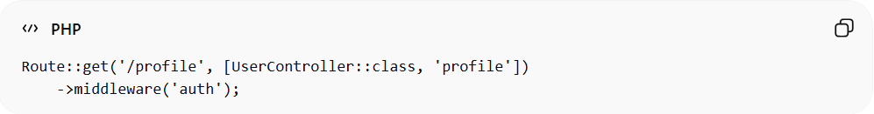
Route::get('/profile', [UserController::class, 'profile'])
->middleware('auth');
👉 Only logged-in users can access /profile

2️⃣ Custom Authentication Middleware
# Source: AI Source: Provided by: [Data Path: Persons Table -> ID Column: 1, Name_En Column: Motasem Essam] -> From: [ChatGPT] on [1/23/2026]
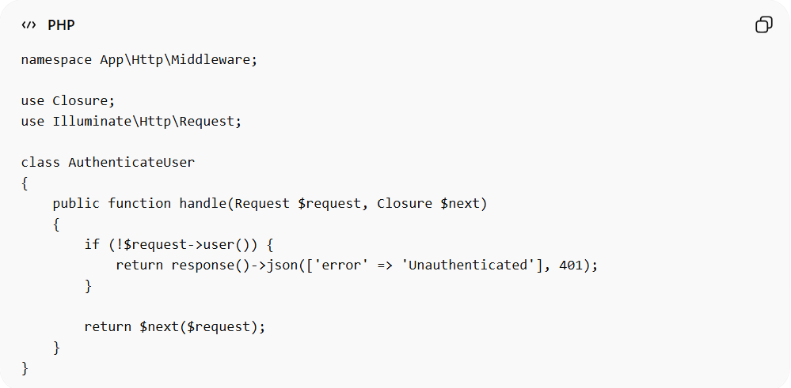
namespace App\Http\Middleware;

use Closure;
use Illuminate\Http\Request;

class AuthenticateUser
{
public function handle(Request $request, Closure $next)
{
if (!$request->user()) {
return response()->json(['error' => 'Unauthenticated'], 401);
}

return $next($request);
}
}

3️⃣ Token-Based Authentication (API)
# Source: AI Source: Provided by: [Data Path: Persons Table -> ID Column: 1, Name_En Column: Motasem Essam] -> From: [ChatGPT] on [1/23/2026]
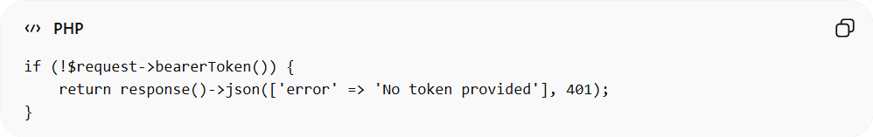
if (!$request->bearerToken()) {
return response()->json(['error' => 'No token provided'], 401);
}
👉 Used in APIs with JWT or API tokens

❌ Bad Example (No Middleware)
# Source: AI Source: Provided by: [Data Path: Persons Table -> ID Column: 1, Name_En Column: Motasem Essam] -> From: [ChatGPT] on [1/23/2026]
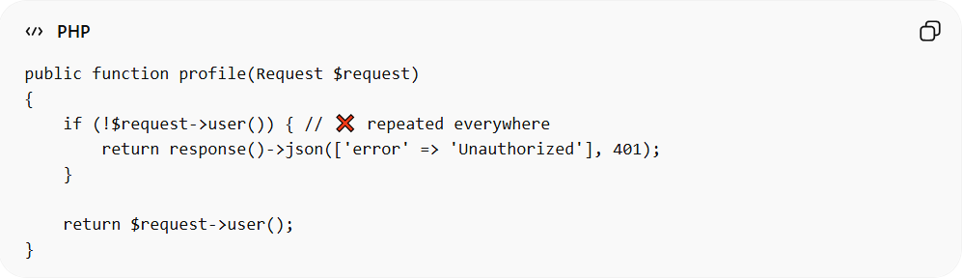
public function profile(Request $request)
{
if (!$request->user()) { // ❌ repeated everywhere
return response()->json(['error' => 'Unauthorized'], 401);
}

return $request->user();
}
Problems:
- Repeated logic ❌
- Hard to maintain ❌
- Violates DRY ❌

✅ Good Example (Using Middleware)
# Source: AI Source: Provided by: [Data Path: Persons Table -> ID Column: 1, Name_En Column: Motasem Essam] -> From: [ChatGPT] on [1/23/2026]
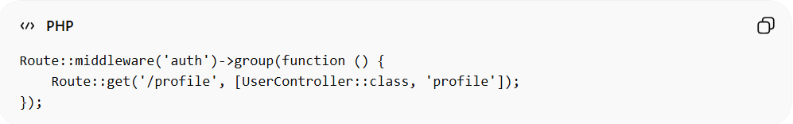
Route::middleware('auth')->group(function () {
Route::get('/profile', [UserController::class, 'profile']);
});
- Centralized authentication ✅
- Cleaner controllers ✅
- Reusable logic ✅

🔄 Authentication vs Authorization
# Source: AI Source: Provided by: [Data Path: Persons Table -> ID Column: 1, Name_En Column: Motasem Essam] -> From: [ChatGPT] on [1/23/2026]
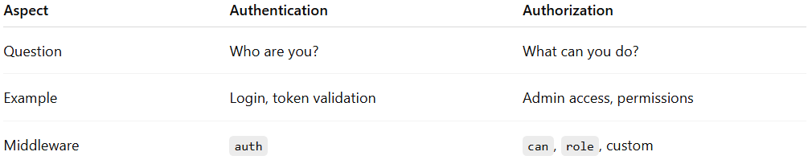
Aspect | Authentication | Authorization
Question | Who are you? | What can you do?
Example | Login, token validation | Admin access, permissions
Middleware | auth | can, role, custom

⚠️ Common Mistakes
# Source: AI Source: Provided by: [Data Path: Persons Table -> ID Column: 1, Name_En Column: Motasem Essam] -> From: [ChatGPT] on [1/23/2026]
- Mixing authentication with authorization ❌
- Writing auth checks inside controllers ❌
- Not using built-in middleware ❌

💡 Key Idea
# Source: AI Source: Provided by: [Data Path: Persons Table -> ID Column: 1, Name_En Column: Motasem Essam] -> From: [ChatGPT] on [1/23/2026]
Authentication Middleware ensures that only verified users can access your application, acting as the first security layer.

🧾 Summary
# Source: AI Source: Provided by: [Data Path: Persons Table -> ID Column: 1, Name_En Column: Motasem Essam] -> From: [ChatGPT] on [1/23/2026]
- Verifies user identity
- Blocks unauthenticated requests
- Works with sessions, tokens, or API keys
- Keeps controllers clean and secure

